**Casual Auto Site**

Causal Auto Site aims to provide services and details for said services to our customers.

Project Members – Tyler Blakemore

Team member tasks – I do everything myself (Wooo)

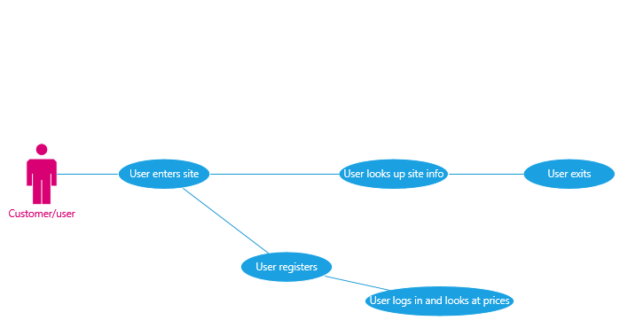

User enters the site – Self explanatory

User looks up site info – The user will be able to navigate to different pages to look up information, such as services, about us and contact details

-User registers – The user will have the option to register to our site, providing them with more details

User logs in and looks at prices – When the user logs in after registering they’ll be able to look up more details, most importantly, they’ll be able to see prices on our services and then use the contact page to schedule an appointment.